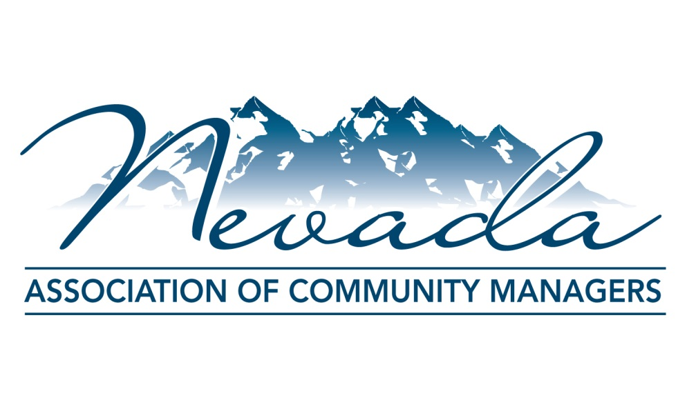

The Nevada Association of Community Managers (NACM) is an organization designed to bring Community Managers together to address topics, policies and laws that effect the Common Interest Community industry as a whole as well as to support and help educate its own members. Membership is limited to licensed Nevada Community Managers and affiliates who are also within the industry, but the focus is on the support of and pooling the knowledge of the Community Managers themselves.

NACM supports the group of individuals who actually implement and work within the industry day after day. HOAs in the state have branches that reach out and touch literally hundreds of thousands of Nevadans. From individual homeowners to Board members to contractors to the Real Estate Division itself, it is the Community Manager who is the hub for all things related to HOA’s and they are the ones tasked with the responsibility of pulling all of the components needed to run a community together.

Each community can be like a city within a city, and just like real cities, these come with their own individual set of governing documents and applicable laws. Being responsible for knowing and adhering to every applicable process, protocol and law that govern all of those “cities” can be challenging. This is where NACM comes in. The goal of NACM is to bring Managers together to discuss various topics and to be a resource for those Managers to turn to when they have questions on establishing best practices. Managers are tasked not only with understanding and implementing the laws and processes that govern the industry, but are also the keys in educating the Boards and homeowners on those same laws. From properly insuring the funds of the Association to ensuring the roads are paved to balancing budgets when 35% of a community is not paying assessments due to a bad economy, Community Managers touch every aspect of the industry from blades of grass to [NRS116](http://www.leg.state.nv.us/NRS/NRS-116.html) and everything in between. We are involved in an HOA from when it is vacant dirt lots to when it is developed into a single family home, condominium or billion dollar high-rise.

NACM members are the ones on the front lines of the Common Interest Community industry and are the people who directly work with and understand the aspects, implications and consequences that come from legislation. To have a resource to use when there are questions on how something would truly effect the entire picture is invaluable. NACM and its members are that resource.

**Email:** [NACM@NacmOnline.net](mailto:NACM@NacmOnline.net)

**Web:** [www.NACMonline.net](http://www.NACMonline.net)

**Phone:** 702-951-1411

**Mailing Address**: P.O. Box 35758 | Las Vegas, Nevada 89133

**Facebook:** https://www.facebook.com/theNACM